Docker is useful for running the software on servers and cloud based paltforms
Docker is useful for installing and running the software without installing any dependencies
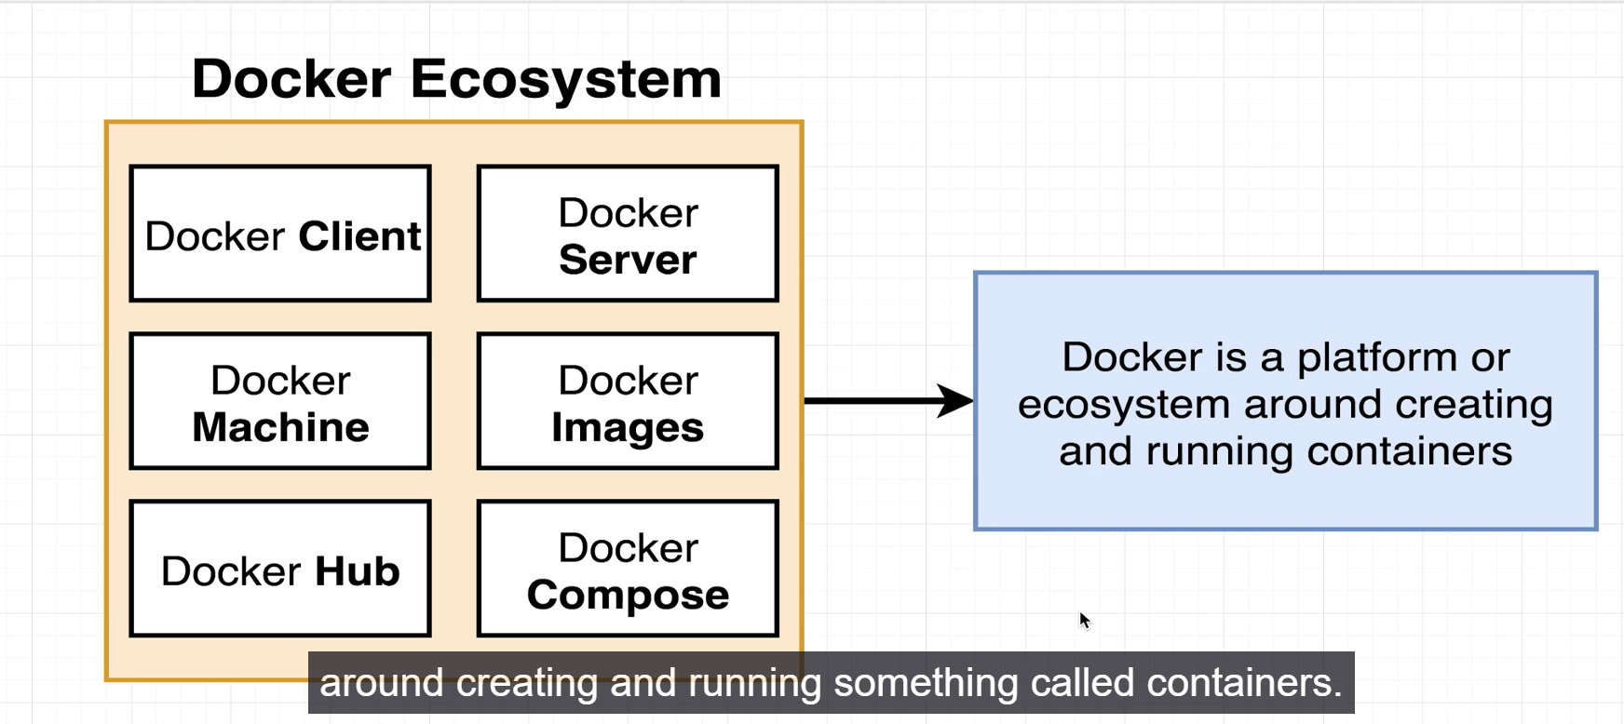

Wsl windows subsystem for linux
Few commands :
- Wsl --version
- Wsl --list --online it will show all subsystem list in the wsl. If you want to install particular subsystem then we need to execute one command
- Wsl --install -d <ubuntu>
Docker main terminology :
1.Container : Container is a program, its contain own hardware systems(container is instance of image)
2.Image : image contains containers( while installing the reddis software it will install the image)
3.Volume

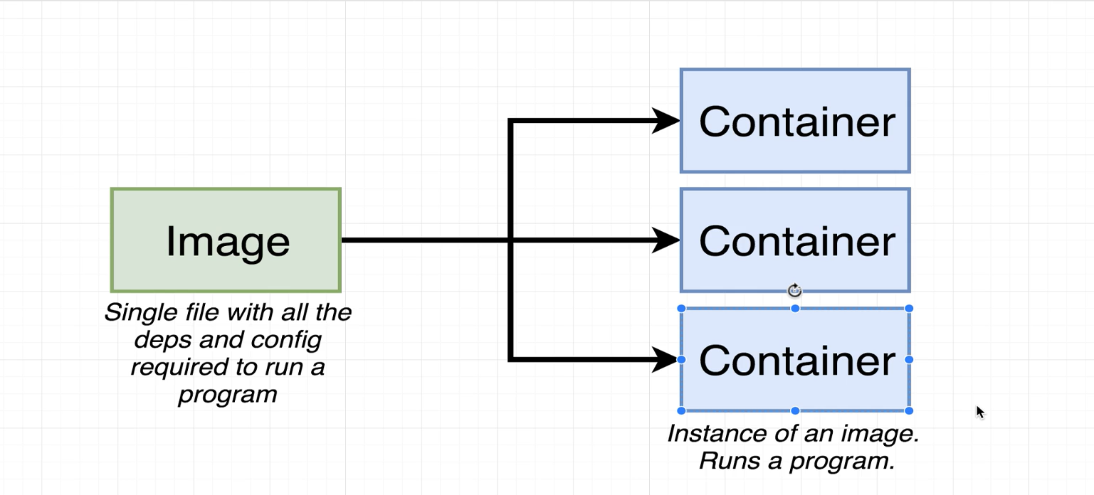

Image : An image contains all dependencies and configurations required to run the program
This image is single file which download and store in hardware drive
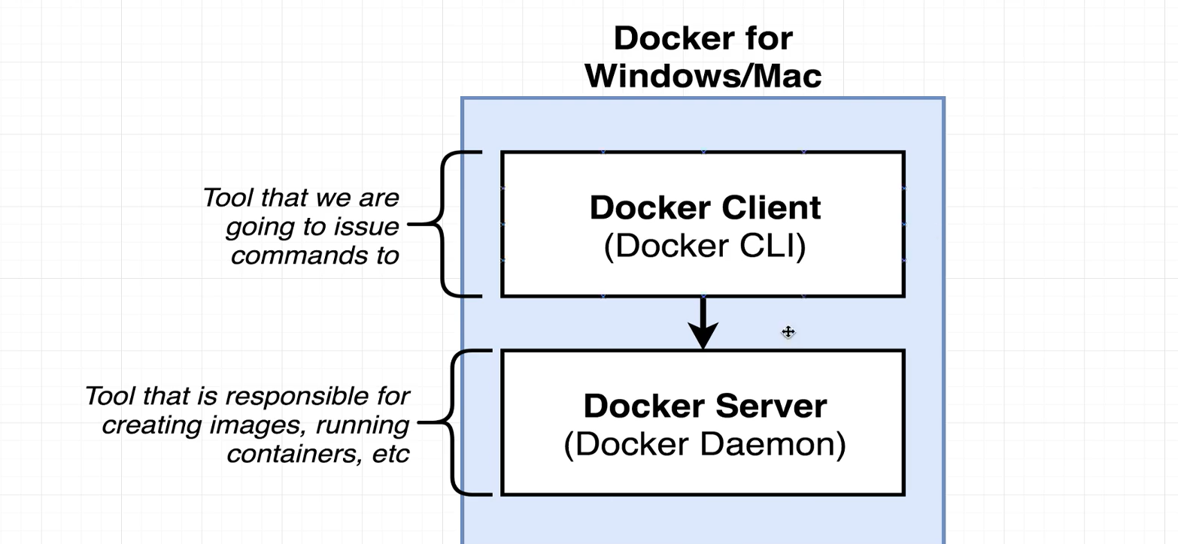

Docker ps this command will show all running containers
Docker run busyhour ping google.com It will provide ipaddress and show how many sec took to respond
Docker ps –all

